EC2 Task
- Launch one EC2 using Amazon Linux 2 image and add a script in user data to install Apache.

Launched Ec2 instance using Amazon Linux 2 image with a script in user data

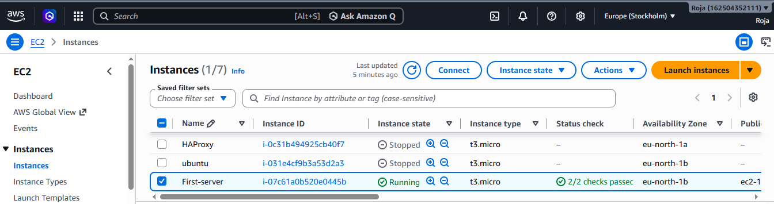
Verified the same on webpage using http://<Ipaddress> and could see the below output:
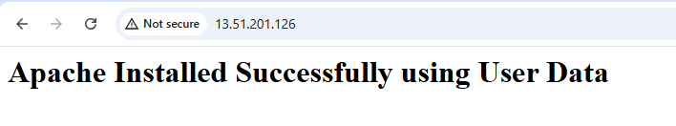

2. Launch one EC2 using Ubuntu image and add a script in user data to install Nginx.

Launched Ec2 instance using Ubuntu image with script in user data to install Nginix.
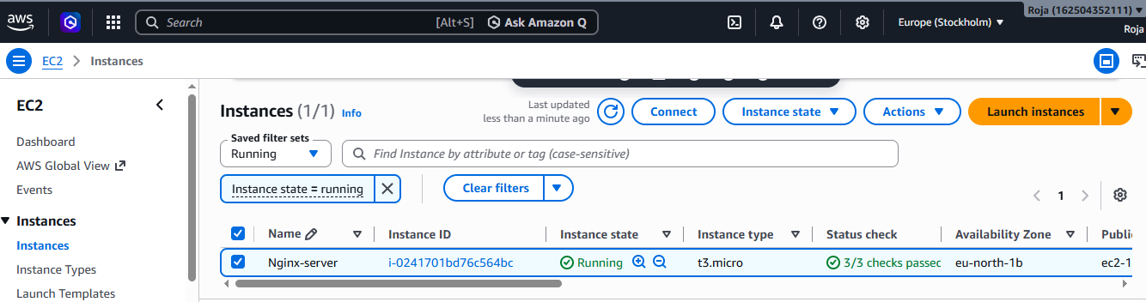

Accessed the same on webpage using http://<Ip address> and could see the below output:

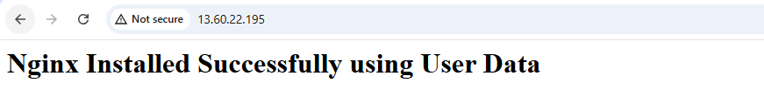

3. Launch one Windows server and install Tomcat on Windows.

Launched Windows server and windows with RDP and connected to the server.

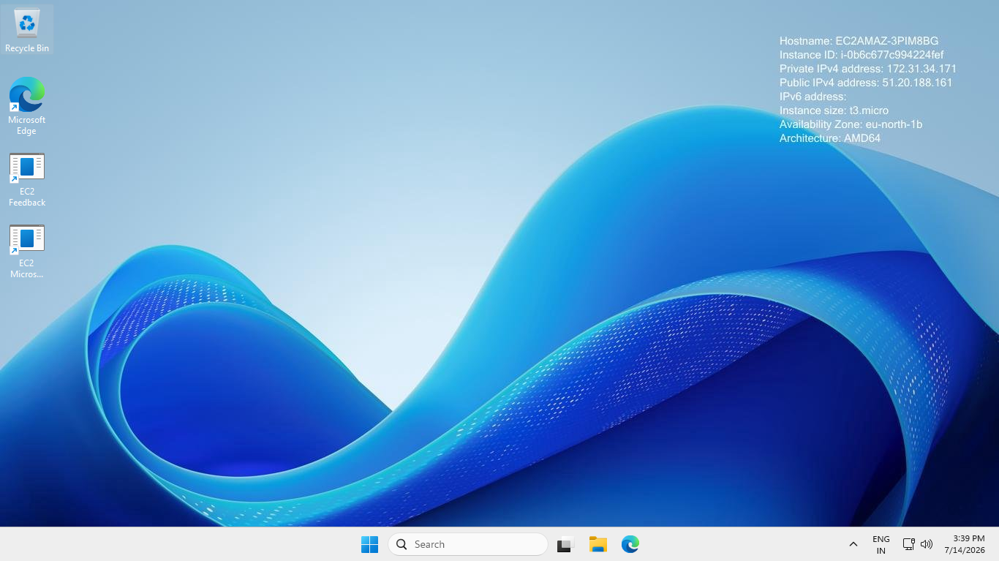

Verified Java_Home
Java version and Javac version
After downloading Java in browser, extracted it to cd \tomcat folder
Then started Tomcat using startup.bat
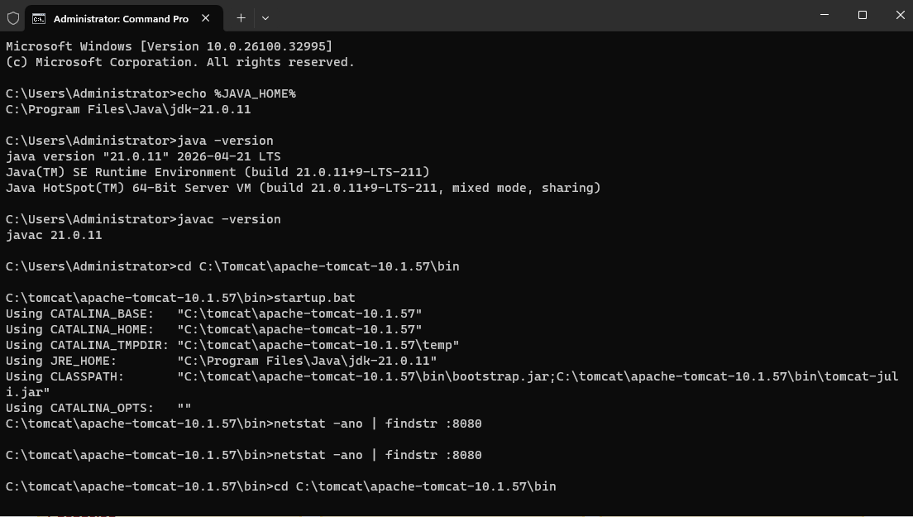
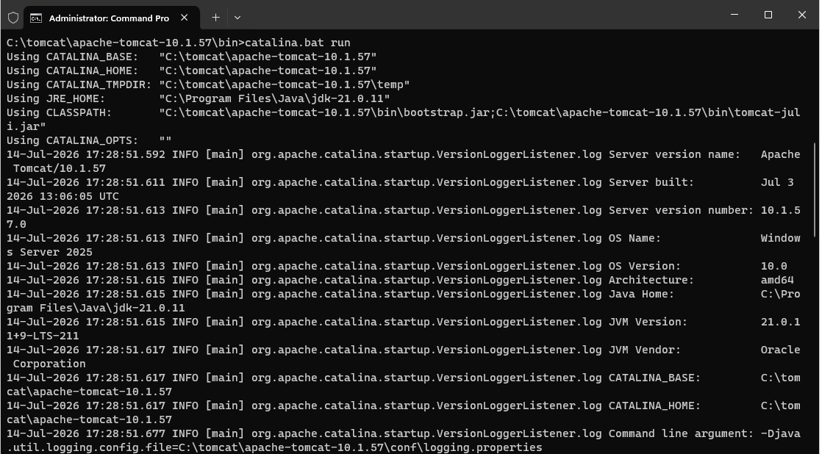

Verified the same on webpage using http://<Ip address> and could see the below output:
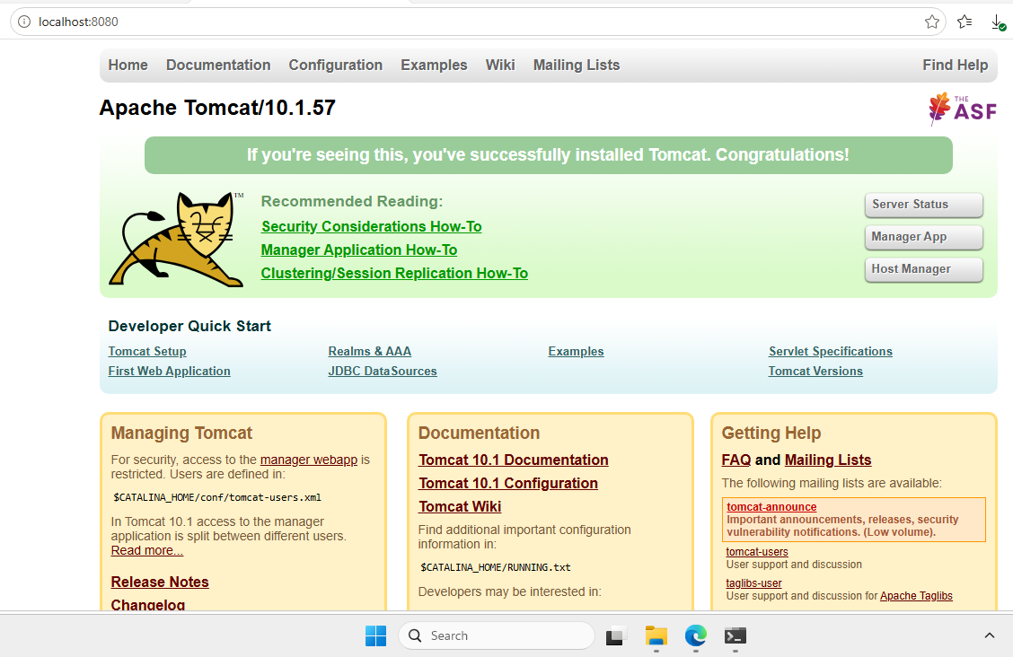

4. Take a snapshot of the instance created in Task 1.

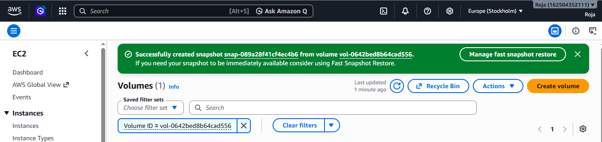

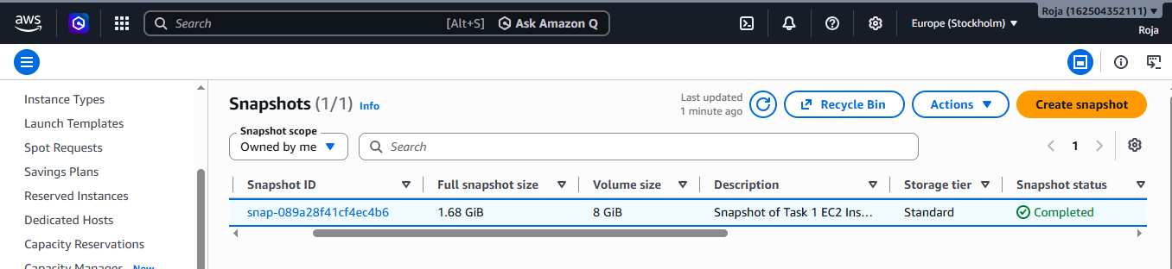

5. Assign passwordless authentication for the EC2 created in Task 2.

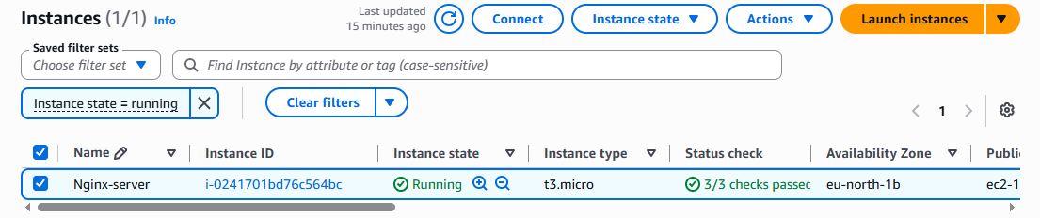

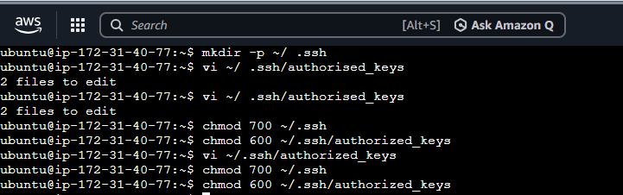

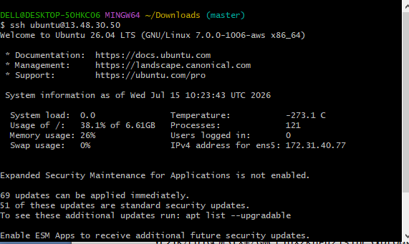

6. Launch any EC2 using the spot purchasing option.

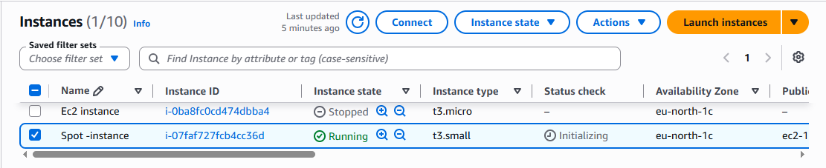

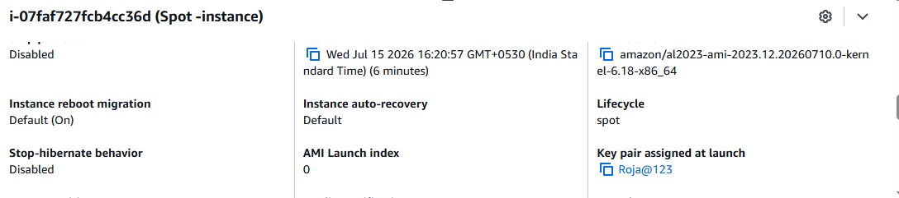

7. Enable termination policy on the EC2 created in Task 2.

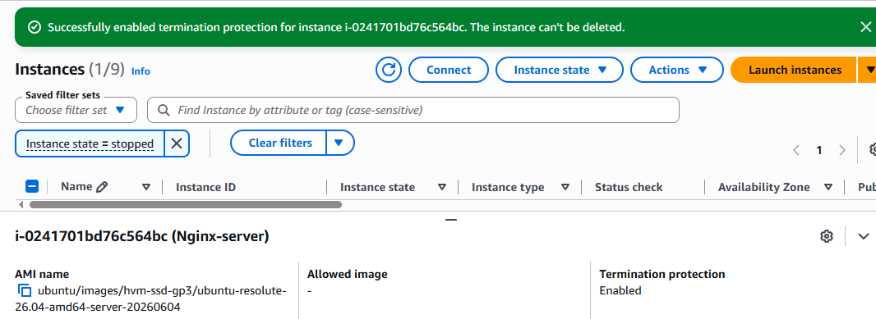

8. Launch one EC2 using AWS CLI

